На основе базы данных AdventureWorks постройте свою базу данных с таблицей фактов и таблицами измерений, по схеме "Звезда".

Я взял таблицы:

Product, SalesOrderDetail, SalesOrderHeader

Звезда состояла из:

FctSales, DmnDate, DmnOrder, DmnProduct

**Создание таблиц**

**Таблица фактов**

FctSales

INSERT INTO [dbo].[FctSales]

([ProductID]

,[SalesOrderID]

,[OrderDate]

,[OrderQty]

,[UnitPrice]

,[ModifiedDate])

SELECT d.[ProductID]

,d.[SalesOrderID]

,h.[OrderDate]

,d.[OrderQty]

,d.[UnitPrice]

,d.[ModifiedDate]

FROM [Sales].[SalesOrderDetail] d

INNER JOIN [Sales].[SalesOrderHeader] h on d.SalesOrderDetailID = h.SalesOrderID

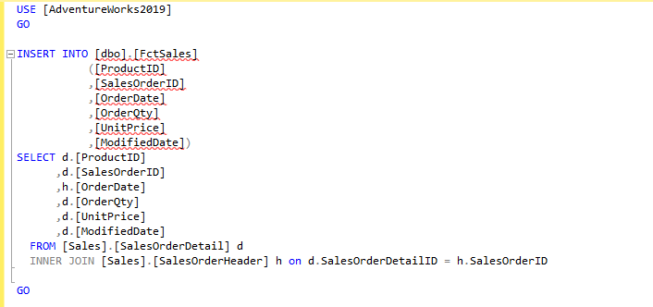

**Запрос select**

select f.ProductID, f.SalesOrderID, f.OrderDate, sum(f.OrderQty * f.UnitPrice) as Sum

from [dbo].DmnProduct p, [dbo].DmnOrder h, [dbo].DmnDate d, [dbo].FctSales f

where

f.ProductID = p.ProductID and

f.SalesOrderID = h.SalesOrderID and

f.OrderDate = d.OrderDate

group by

f.ProductID, f.SalesOrderID, f.OrderDate

**Таблица измерений**

DmnDate

INSERT INTO [dbo].[DmnDate]

([OrderDate]

,[DueDate]

,[ShipDate]

,[Status]

,[SalesOrderNumber]

,[TerritoryID]

,[ModifiedDate])

SELECT d.[OrderDate],

d.[DueDate],

d.[ShipDate],

d.[Status],

d.[SalesOrderNumber],

d.[TerritoryID],

d.[ModifiedDate]

FROM [Sales].SalesOrderHeader d

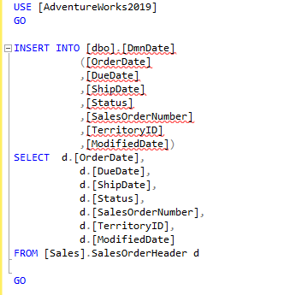

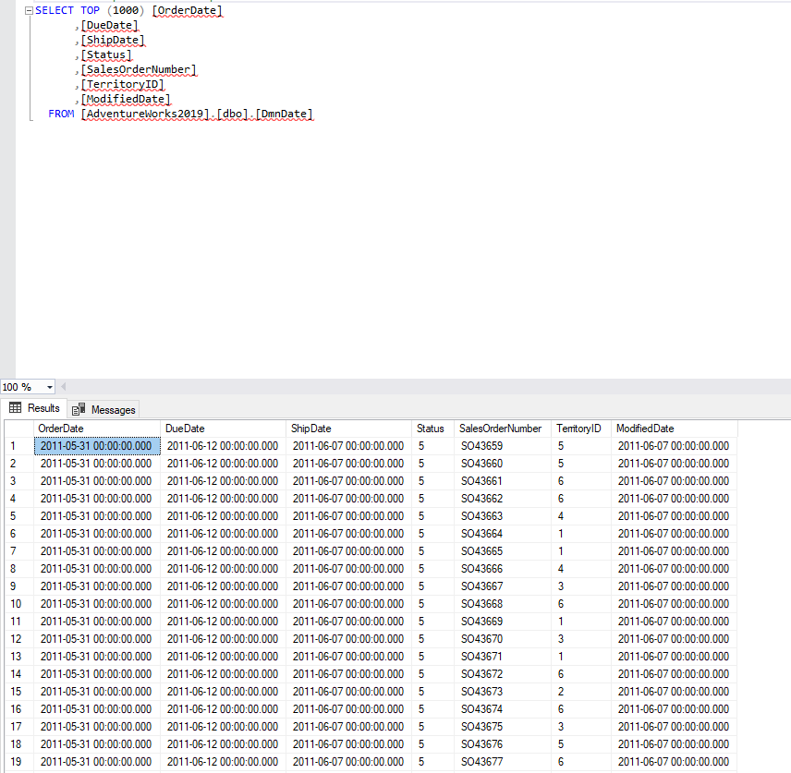

DmnOrder

INSERT INTO [dbo].[DmnOrder]

([SalesOrderID]

,[SalesOrderNumber]

,[AccountNumber]

,[CreditCardID]

,[OrderDate]

,[ModifiedDate])

SELECT d.[SalesOrderID],

d.[SalesOrderNumber],

d.[AccountNumber],

d.[CreditCardID],

d.[OrderDate],

d.[ModifiedDate]

FROM [Sales].SalesOrderHeader d

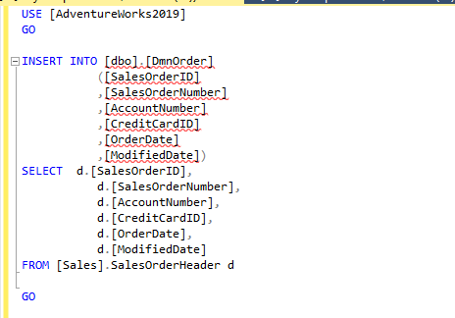

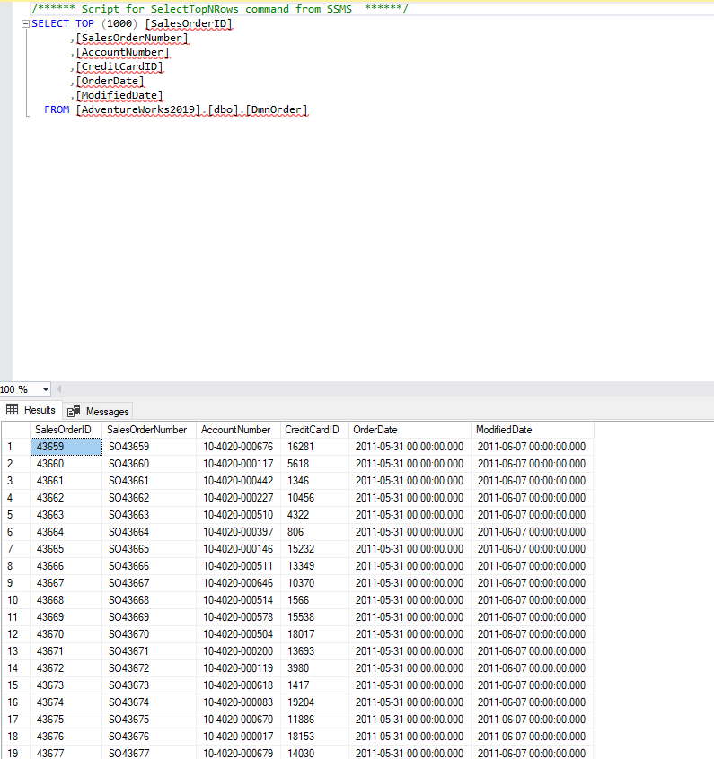

DmnProduct

INSERT INTO [dbo].[DmnProduct]

([ProductID]

,[CarrierTrackingNumber]

,[SpecialOfferID]

,[UnitPriceDiscount]

,[LineTotal]

,[ModifiedDate])

SELECT d.[ProductID],

d.[CarrierTrackingNumber],

d.[SpecialOfferID],

d.[UnitPriceDiscount],

d.[LineTotal],

d.[ModifiedDate]

FROM [Sales].SalesOrderDetail d

